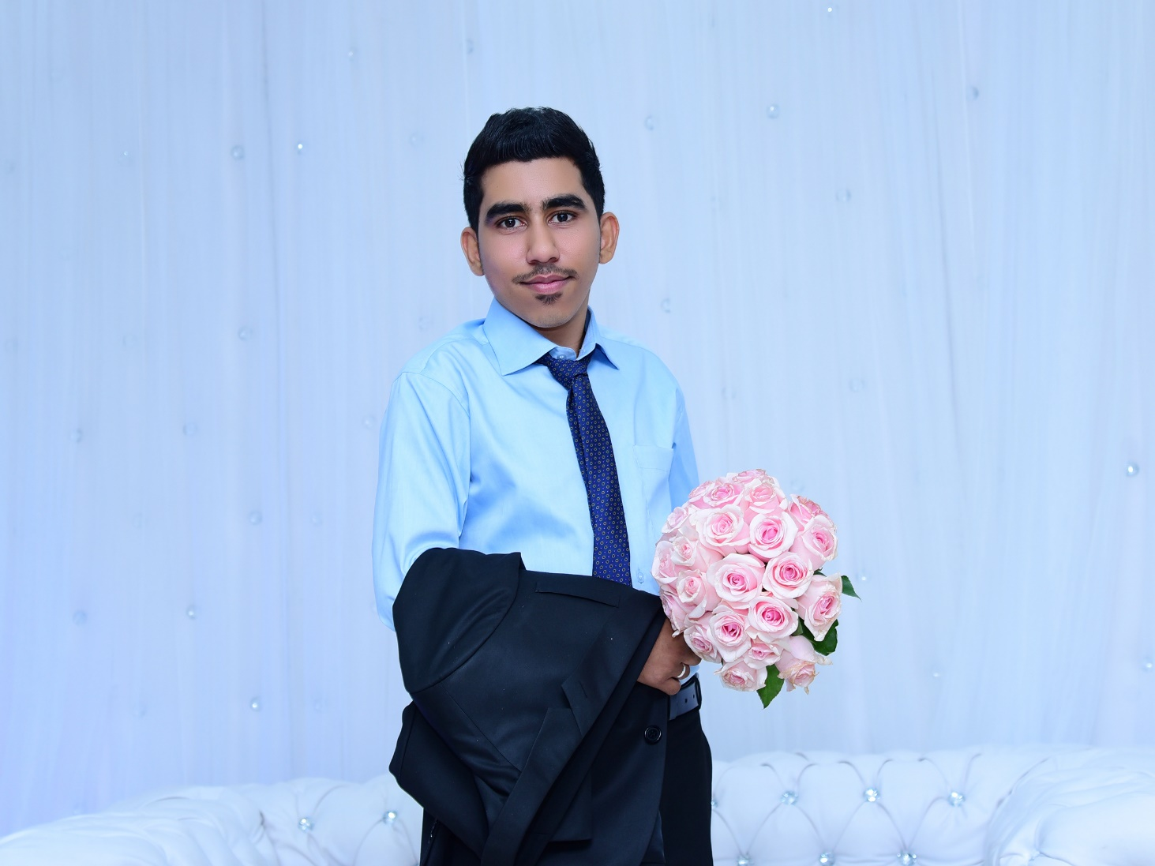

c.v

***N*am*e:*** **Ahmed Abdulla Habib Abdulla Ali**

# contact information

**Address** Villa 1634 Road1955 Block419 Jidhfs-kingdom of Bahrain

**E-mail** dkdkdk4442@gmail.com

**Telephone** 34373719 - 33276032

# personal Informaion

* Nationality: Bahraini
* Date Of Birth: 04/10/1994
* Place Of Birth: Jidhfs - Bahrain
* Marital: married

# Objective

I am looking for a job in the field of Retail

And find myself efficiently in the job of a sales and customer service and is able to manage group of staffs

# Education

|  |  |  |  |
| --- | --- | --- | --- |
| **Qualification** | **Institute / school** | **From** | **To** |
| Secondary school | Alnoaim Secondary school  (General Certificate in Languages and Humanities) | 2010 | 2013 |

# traning cours

* Customer Service courses
* Certificate (essential sales skills)
* Attended 2.3 IntB elementary 3 (general English ) of British council

# Experience

**Position company From To**

**Sales associate &Cashier Al Rashid group 2014** Present

# Skills

* Computer Skills
* MS Office
* Working Under Pressure.
* Teamwork
* Hard Worker.
* Communication skills.
* I have the ability to work individually and work together to achieved of job requirement

# Language

* Arabic –Fluent
* English – Good
* Indian _ Good
* Philippines _ Good

# references

References are furnished upon request